Keeping kids and families active during COVID-19 virus isolation

Physical and Mental well-being is so important to us all. Here are some fun & simple ideas to get children and adults ‘up and active’ in keeping fit and healthy during their time not in school.

We hope you enjoy having a go at some of these activities.

Somerset Activity and Sports Partnership

Keep a look out on our twitter @somschoolgames and our website for more information www.sasp.co.uk

(Thanks to Dartmoor School Sport Partnership team for sharing)

Physical activity Score card – Keeping kids and families active during isolation
Activity | Picture of how do the activity | Score | Score | Score | Score | Score | Score
Press up  How many press ups can you do in a row without stopping  (choose your level) | 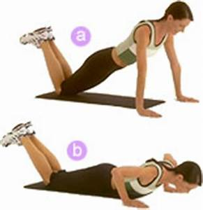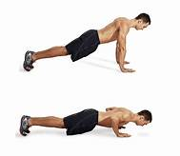  Easy Hard
Burpees  How many burpees can you do in a row? | 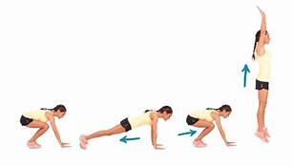
Sit ups  How many sit ups can you do in a minute | 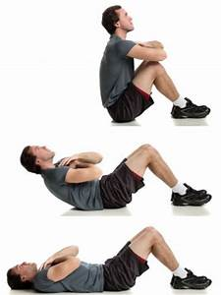
Skipping with a rope  how many skips can you do in a minute | 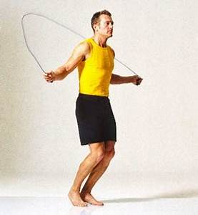
Wall sits easy  how long can you sit against the wall, without moving | 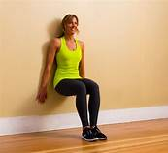  Easy Hard
Plank  Can you hold the plank  30 seconds easy  40 seconds medium  60 seconds hard | 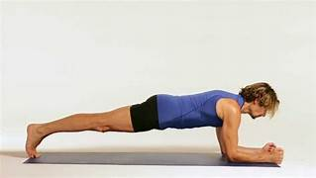
Squats  Choose a level  EASY – 30 seconds  MEDIUM – 45 seconds  HARD – 60 seconds | 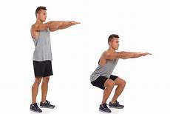
Scissor kicks  Choose one of the levels for the scissor kicks;  EASY – 20 seconds  MEDIUM – 40 seconds  HARD – 1 minute | 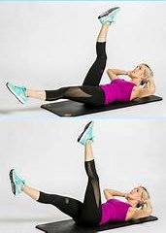
Lunges  Choose a level  EASY – 30 seconds  MEDIUM – 45 seconds  HARD – 60 seconds | 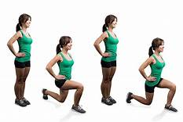
Spiderman plank  EASY – 30 seconds  MEDIUM – 45 seconds  HARD – 60 seconds | 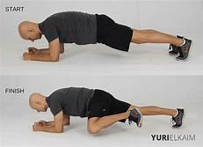
Side lunges
EASY – 30 seconds
MEDIUM – 45 seconds
HARD – 60 seconds

Other Physical Activities to try at home
https://www.sportengland.org/news/how-stay-active-while-youre-home
Sport England have produced tons of resources to help keep you active, over this time of isolation
- GoNoodle
www.gonoodle.com fun dance moves and active games online. Free to subscribe – tons of fun activities which the children will be familiar with as many schools use this site for brain breaks and wet play.

- Jo Wicks ‘The Body Coach’ workouts on you tube – He has some brilliant sessions aimed at kids and safe for all the family.
Eg:
https://www.youtube.com/watch?v=0xE3CppbVeA
https://www.youtube.com/watch?v=TUp2_VAHIrI
https://www.youtube.com/watch?v=xLHA5g-82vY

- NHS 10 minute workouts
https://www.nhs.uk/live-well/exercise/10-minute-workouts/

- Set an Indoor scavenger hunt
Find the following items in your house. Use a phone or tablet to take pictures of the following items. How quickly can you find all the items?
- Something beginning with the letter C
- Something red
- A family photo
- A spoon
- A picture of someone doing a yoga pose
- Happy faces
- Something beginning with the letter O
- Something that makes a noise when shaken
- Something beginning with R
- Something soft
- Something white
- Something with two hands and a face but has no arms or legs
- A group balance, where all of you are touching each other, no one can do the same balance
- Someone doing the floss
- Something plastic
- Something hard

- Set some Personal challenges!
1.Stork balance
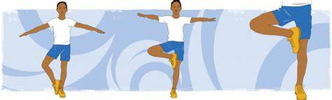
How long can you balance on one leg.
Now do the do the same balance but close your eyes.
Can you beat your score? Who in the family can hold this balance the longest?
2. Plank challenge
Who can hold the following plank poses for the longest?
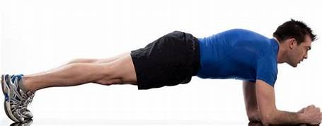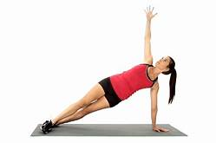

3. Football Keep ups & Freestyle challenges
https://www.youtube.com/watch?v=vnfg1u7tX5o
https://www.youtube.com/watch?v=J3-h3MV0yNw

- Yoga exercises
Try holding these yoga poses.
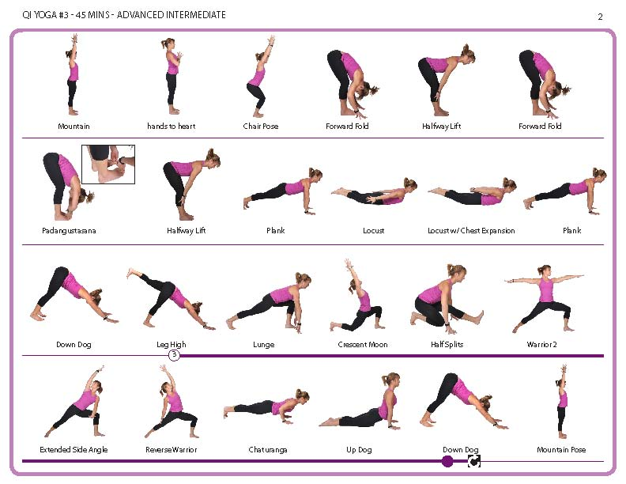
If you like these poses below, try finding more on line.

There are some brilliant resources online too that would be good to include:

https://www.unicefkidpower.org/fun-sports-activities-games-resources-kids/
https://www.sportsrec.com/5185418/indoor-sports-activities-for-kids
https://kids.guinnessworldrecords.com/activities/try-this-at-home-backyard
https://www.verywellfamily.com/active-play-4157315
https://www.homeschooling-ideas.com/kids-sports-activities.html
https://www.homeschooling-ideas.com/homeschool-pe.html
https://familyeguide.com/boredom-busters-110-fun-at-home-activities-for-families-kids-2/

plus loads of stuff on youtube eg:
https://www.youtube.com/watch?v=WmGjxU3Ggko
https://www.youtube.com/watch?v=o8uTdn_zkok
https://www.youtube.com/watch?v=dhCM0C6GnrY
https://www.youtube.com/watch?v=8y6bIbr-Hn0

Plus…….we are sure you have tons of ideas yourselves!

Stay Healthy, Keep Active and we look forward to seeing you all very soon and hearing all about the fun you have had at home staying active!

