STOGURSEY CofE PRIMARY
“Let your light shine”
Mt5 v16

Complaints policy

2019

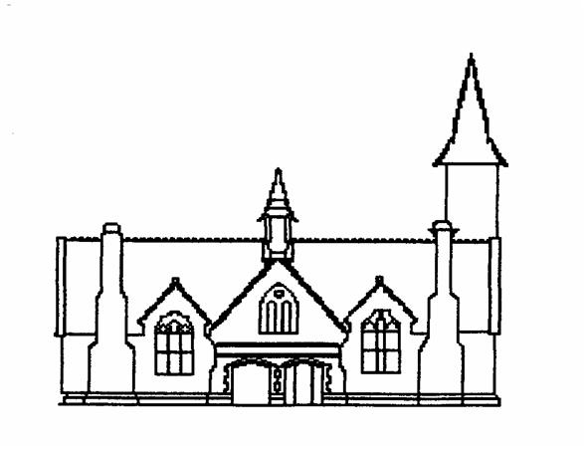

Approved by the governing Body of Stogursey C of E VA Primary School
Chair of Governors Anna Hammond
Date 12th June 2019
Head Teacher Gary Tucker
Date 12th June 2019

Date of Review June 2020

Complaints Policy
We believe that our school provides a good education for all our children, and that the headteacher and other staff work very hard to build positive relationships with all parents. However, the school is obliged to have procedures in place in case there are complaints by parents. The following policy sets out the procedure that the school follows in such cases.
Aims and objectives
Our school aims to be fair, open and honest when dealing with any complaint. We give careful consideration to all complaints and deal with them as swiftly as possible. We aim to resolve any complaint through dialogue and mutual understanding and, in all cases, we put the interests of the child above all other issues. We provide sufficient opportunity for any complaint to be fully discussed, and then resolved.
The complaints process
How to share a concern
If a parent is concerned about anything to do with the provision that we are providing at our school, they should, in the first instance, discuss the matter with their child’s class teacher. Most matters of concern can be dealt with in this way. All teachers work very hard to ensure that each child is happy at school, and is making good progress; they always want to know if there is a problem, so that they can take action before the problem seriously affects the child’s progress.
What to do if the matter is not resolved through informal discussion
Where a parent feels that a situation has not been resolved through contact with the class teacher, or that their concern is of a sufficiently serious nature, they should make an appointment to discuss it with the headteacher. The headteacher considers any such complaint very seriously and investigates each case thoroughly. Most complaints are normally resolved at this stage.

Sharing a concern about the headteacher
Should a parent have a complaint about the headteacher, s/he should first make an informal approach to one of the members of the governing body, who is obliged to investigate it. The governor in question will do all s/he can to resolve the issue through a dialogue with the school, but if a parent is unhappy with the outcome, s/he can make a formal complaint, as outlined below. A list of governor names is available from the school office or on the school website.
How to take the matter further
Only if an informal complaint fails to resolve the matter should a formal complaint be made to the governing body. This complaint must be made in writing, stating the nature of the complaint and how the school has handled it so far. The parent should send this written complaint to the Chair of Governors.
The governing body must consider all written complaints within three weeks of receipt. It arranges a meeting to discuss the complaint, and invites the person making it to attend the meeting, so that s/he can explain her complaint in more detail. The school gives the complainant at least three days’ notice of the meeting.
After hearing all the evidence, the governors consider their decision and inform the parent about it in writing. The governors do all they can at this stage to resolve the complaint to the parent’s satisfaction.
Who to appeal to next
If the complaint is not resolved, a parent may make representation to the LEA. A further meeting is chaired by an independent person, who considers all the evidence and makes a further judgement in an attempt to resolve the complaint.
If any parent is still not content that the complaint has been dealt with properly, then s/he is entitled to appeal to the Secretary of State for Education.
Monitoring and review
The governors monitor the complaints procedure, in order to ensure that all complaints are handled properly. The headteacher logs all complaints received by the school and records how they were resolved. Governors examine this log on an annual basis.
Governors take into account any local or national decisions that affect the complaints process, and make any modifications necessary to this policy. This policy is made available to all parents, so that they can be properly informed about the complaints process.

