December 2019

Time flies when you are having fun! I can’t believe Christmas is upon us. Where has the time gone?
The positive energy flooding our school has been amazing this term. I wanted to share with you some really positive things that I have seen in our school recently.

In Pre-School, it has been incredible to see the children interacting with the interesting activities that have been put on. I watched two-year-olds cooking, making biscuits and in another activity, cutting up dough for fine-motor skills work. This included picking up fiddly items with tweezers.

I was really thrilled to see members of the public and representatives from EDF popping along to see the Shine Fest (see below) and the praise we received from them in our comments book brought warm feelings to my heart. Here they are:

"Great artwork- loved the film. Great imagination!"

"An inspiring exhibition with such obvious pride in their work. Well done all!"

"Brilliant! Love the pixies and the variety of medium used. A wonderful experience for my daughter. Thank you."

"Loved the animals printed on the fabric."

I’m sure you’ll agree that yes, things are changing in Stogursey school but all for the better. Our school has turned into a bustling hive of activity

and the children are really taking advantage of everything we have to offer. This is great.

I wish you and your family a Merry Christmas and a Happy New Year. Have a peaceful, restful holiday and

I look forward to seeing everyone back on 6th January to begin the next term with what already looks to be just as exciting as this term!

Mr Tucker 


ILLNESS

We have had many children and some staff off very poorly with the bug that seems to have swept its way through most schools in the area! This has really dented our attendance figures but this bug has been particularly nasty and so rest and recuperation is what is needed. Haygrove School shared a handy guide to illness from the NHS and it is at the bottom of this newsletter.
We have done some work with all the children around basic hygiene and handwashing to attempt to prevent the spread of illnesses. Staff have also taken extra care to disinfect equipment, chairs and tables so we can play our part in this.

If you are worried about your child’s attendance or health, then please do pop in for a chat.

SHINE FEST EXHIBITION AND LIBRARY
We had a lovely time as the children exhibited their work from over the term. It’s been so lovely seeing the children working with Alice Maddicott (writer from Halsway Manor) and Harriet Popham (local

artist) and seeing the work going up in our new exhibition space in the school where the library used

to be. The children are so proud of what they have achieved and rightly so!

The school library has been moved following a decision from the Smart School Council to revamp it with the theme of ‘Under the Sea’. This is taking shape and although not finished, it promises to be a very inspiring space that celebrates and promotes books and a passion for reading.

GOODBYE AND THANK YOU

Many thanks to Caren Egan, who kindly stepped in to run our Pre-School on a temporary basis. Caren is returning back to her role having been seconded from Bridgwater & Taunton College. I’m sure you’ll agree that she has really brought some exciting ideas both inside and outside in our Early Years setting and the children are making fantastic progress as a result. It is a shame to see Caren go but it was only ever temporary.

We are doing the final recruitment of permanent staff for the Pre-school but we should be able to announce the new line-up shortly. Pre-school returns on 6th January, as will the rest of the school.

HEAD LICE
We have had a few cases of Head Lice in all the classes recently. Just a gentle reminder to please follow procedures regarding this so children aren’t in discomfort.

SMART SCHOOL COUNCIL

You may have heard of this exciting new development (kindly sponsored by FOSS) which is the next level in

Pupil Participation and engagement. The children are really enjoying this and it teaches them more about British Values such as Democracy, rule of law and

tolerance. Below is a diagram of what the structure is to the Smart School Council.
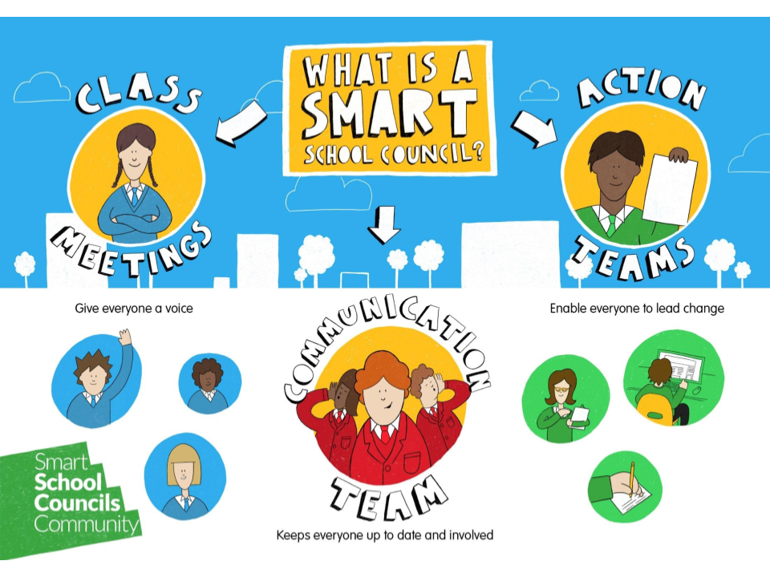
Here are the main differences between a school council and a smart school council.
Normal School Council | Smart School Council
- Elected reps from each class make decisions  - The reps try to make changes  - Teachers end up doing all the work  - Discussing issue and buying new playground equipment | - All children vote on decisions (class meeting)  - Communication team leads it and keeps everyone updated  - Communication and Action Teams solve problems and make change happen  - Children can lead campaigns, take social action or set up clubs or initiatives that they care about

These are the main differences and although it is in its infancy, we are confident that this is a better way forward to let the children be more active in the school and develop things that they care about. They will also learn useful character-building, life skills through this such as conflict resolution, discussion and debating skills as well as caring for the future of our school.

WE ARE RECRUITING
We need a Pre-School Assistant. The advert for this job is on the QET website at https://www.quantockedtrust.co.uk/vacancies

This is an exciting opportunity to take part in our exciting work on enhancing our Early Years provision and be part of a wonderful team. If you know anyone or are interested yourself, please either check the website or pop in to have a chat with Mr Tucker or Miss Day.

CHURCH SERVICE
Please can all parents/guardians bring the children to the church for 5.30 on Thursday 19th December, so that they can change into their costumes ready to start at 6.00

DIARY DATES

Newsletters will be sent out in the second week of every month. Please see the website for more information.

These are the dates for this term. We try our best not to change them but sometimes circumstances require us to.

Tues 10th Dec Y5/6 NSPCC Workshop
Weds 11th Dec Christmas Lunch
Thurs 12th Dec Aladdin at Tacchi Morris Theatre Return 5.00pm
Fri 13th Dec Christmas Jumper Day
Fri 13th Dec FOSS Christmas Disco 6-8pm
Thurs 19th Dec Church Service-6pm
Fri 20th Dec Christingle at Church-2pm
Fri 20th Dec Last day of Term 2

Mon 6th Jan Term 3 starts

From the NHS



