September 2019

Welcome back to the new Academic Year at our school. I hope you had a lovely summer holiday and are refreshed, ready to start a new chapter in our school’s history.

It is exciting to be an Academy and part of the Quantock Education Trust along with Haygrove and Spaxton schools. The children have already met Mrs Norman and Mrs Canham from the trust who will be in school every week working with us to achieve amazing things.

As we start on this journey, we will be exploring deeply what Jesus meant by ‘Let your Light Shine’ over this term. Our school’s motto came from the Sermon on the Mount. Over the coming term, we will be learning about the Sermon on the Mount so that we can understand the school vision, values and mission better. With the support of the MAT and the Diocese, we are seeking to make improvements to our school and ensure the Christian message shines through in everything we do.

I am thankful to my newly-recruited Collective Worship Crew (Thomas, William, Jazmine, Riley, Bronte and Matilda) who are leading the way in this and helping to facilitate the exploration of where we are going next as a school spiritually. I look forward to the term ahead and seeing what comes out of this very exciting piece of work.

We start our character-building curriculum topic next week and the first topic is all about the Quantocks. We are going to be engaging in a creative Arts project to enhance this, funded by EDF so this should really help children gain more knowledge and experience. Teachers will be sending out more details about this soon.

As ever, if you would like to get involved in the life of the school, please pop in for chat (after 11am each day please!).

Mr Tucker

BOOK FAIR
The Book Fair will be arriving next week and will have lots of exciting books for all ages. Please come along and have a browse and be part of our journey into becoming a Reading School. A separate letter will be sent out with further details.
Miss May
English Lead

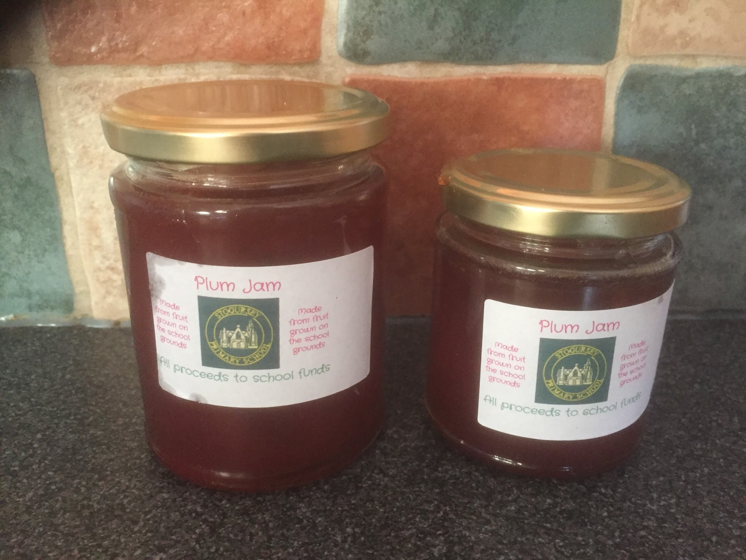
JAM FOR SALE
Over the Summer, Mr Tucker noticed that the two plum trees on the school field were full of juicy, delicious plums. He picked them just in time and turned them into homemade jam. They are on sale at the school office and all proceeds will go towards outdoor education for the children. It is £3 for a large jar and £2 for a smaller one. Please come and get yours before we sell out! There’s about 30 jars. There’s also limited edition Blackberry jam going for the same price.

PARENTS EVENINGS
These will be held in October and dates will be announced shortly.

ALDI VOUCHERS
This September, Aldi are helping support Get Set in promoting a healthy lifestyle for kids. Aldi's kit for schools will be giving out a sticker when a member of the school spends £30 or more in their stores. The stickers collected will be added to a Get Set poster and when we have 300 stickers, our school will be entered into a competition with the chance of winning £20,000 to support our healthy lifestyle ambition. We ask for any stickers collected to be handed into the school office by 16th of November. Thank you for your help.
Miss Atwell
PE & Healthy Schools Lead

WHOLE SCHOOL TRIP- OCTOBER 3RD
As well as having 14 days of funding of artists, poets, writers and musicians working with the school and wider community, we have managed to secure a trip to the Quantocks to work with a storyteller discovering local myths and legends. This trip is scheduled for Thursday 3rd October. We will probably be looking for a few parent helpers to come on this trip as well so please let us know if you can come with us and help.

STOGURSEY ARTS FESTIVAL
As usual, the school will be taking part in the festival. Unfortunately, it coincides with the two INSET days but this will give families an excellent opportunity to take part in the festival. The school will be open on Saturday 26th October 2-4pm to showcase children’s work as well.

CLUBS
After school clubs are slowly springing back to life and a letter is being sent out about this.

Our new-style lunchtimes have started, based around our Christian values. Already, we have had our first thankfulness lunch and plans are afoot for a resilience lunch and a friendship lunch. Visitors have already commented on what a lovely atmosphere this has created.

As part of this, lunch clubs are getting started and children have started to sign up for them. We have a new daily study club for Homework, a new dance club, a new Table Tennis club as well as the old favourites like Running Club and Sports Coaching. As our School Council gets started, we envisage children leading clubs as well and working to gain qualifications such as Sports Leaders and Playground Leaders. Exciting times!

ATTENDANCE
Our final figure as a school was 93.8% attendance last academic year. This is below the target of 96% and we clearly need to improve this. Missing any school has a detrimental effect on the education of pupils. I have done an assembly on this and have introduced the weekly percentage update that is on Alfoxton class window. The children are keen to keep us in the green zone of 97%-100%. Keep an eye on our weekly position and please support us in our efforts.

Having a slight sniffle is not grounds for keeping a child off school. Things like careful planning of appointments out of school time can help us to massively improve our attendance. In July’s issue, I wrote about Term-Time absences. We need to improve and I am looking forward to celebrating our achievements as time goes on.

If you are having difficulties getting your child to school or on time, then please come and speak to us.

DASH VOLUNTEER NEEDED
We would like to fully-train a volunteer to run the before school DASH club as our long-standing volunteer Allen Robins is stepping down. We thank Allen for his hard work and dedication in running this and wish him well.

If you are interested in running this twice a week, ensuring our children start the day with vigorous exercise and a healthy breakfast (provided by FOSS) then please pop in for a chat. The club is 8am-8.55am twice a week.

MAT CONFERENCE
The MAT will be holding its inaugural conference at the McMillan Theatre on our INSET Day of Thursday 24th October. Some of our children will be getting involved in this. Your child will be approached if they are involved and will receive details very soon.

DIARY DATES
Newsletters will be sent out in the second week of every month. Please see the website for more information.
These are the dates for this term. We try our best not to change them but sometimes circumstances require us to.
Tues 10th September Swimming starts
Mon 16th September Book Fayre Week
Thurs 19th September Fire Safety Talks
Thurs 3rd October Whole School Trip
Weds 23rd October Last Day of Term 1 for children
Thurs 24th October INSET/ MAT Conference
Fri 25th October INSET Day

Mon 4th November Term 2 starts
Fri 15th November Y6 Bikeability
Fri 29th November Flu Vaccinations
Thurs 5th/ Fri 6th Dec End of Topic Celebrations
Mon 9th Dec Christmas topic begins

